NGAA West Newsletter
Volume 7 Number 1 ______________________March 2018
In This Issue Page

Lunch program and menu 1
Lunch reservation form 1
NGAA West President’s Message 2
Luncheon Notes 2-3
Renewal of DoD Retiree ID Cards 3
New Members / Address Changes 3
Ill and Departed 3
Alive and Well 4
2018 Board Members 4
Treasurer’s Report 4
NGAA West Sports 5
Points Group News 5
Negative Engravers 5
Photo Lab Breakfast 5
14 Things Our Home Page Can Do 5
On Line Membership Form 6
Calendar of Events 6
Membership Application 7

NGAA West Luncheon
Wednesday, March 28, 2018
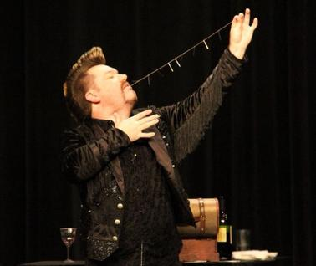
piètro’s
3801 Watson Road
314-645-9263

Program: Master Illusionist Keith Jozsef

Cocktails 11:30 a.m., Lunch 12:00
Price: $20 per person

Choose from the menu below. Selections will be confirmed at the luncheon.
Chicken Ala Pietro – 8 oz. boneless breast of chicken in a white wine and fresh mushroom sauce
Grilled Grouper – Seasoned with Italian breadcrumbs
Veal Parmigiana – Chopped veal cutlet, topped with meat sauce and cheese,
Entrees served with salad, vegetable, a pink sauce pasta, bread and butter, and Chocolate Cake.
Bar purchases will be available from the wait staff on a cash basis only.

----------------------- Print this page and cut on this line ----------------------------

March 28, 2018 Luncheon Reservation Form
Planned Entrée Choice (Confirm at the luncheon. One per Attendee) Chicken Veal Grouper

Member name: __________________________________________ _________ _________ _________
Spouse name: __________________________________________ _________ _________ _________

Guest name: __________________________________________ _________ _________ _________

Check #: ______ .
□ CHECK IF YOU WANT A REMINDER CALL ON TUESDAY, MARCH 27.
Please mail to arrive by MARCH 21, 2018 to:

NGAA West
P.O. Box 510091
St. Louis MO 63151-0091

NOTE: YOU CAN PAY ON LINE. Add NGAA West to your list of on-line payees and make payment. Send an email to treasurer@ngaawest.org or text to 314-973-8227, stating amount paid, names of those attending and your menu selections.

President's Message

Keep your heads up. By the time of our next luncheon we will be two and a half weeks past the start of daylight savings time and one week into Spring. The days will be getting longer, the sun will have crossed the equator with warmer weather to follow, and there will be lots of outdoor activities for you to attend.

Your board of directors met January 9th and February 7th to go over the events you voted for at the December luncheon.

These four activities, with dates and POC.s, are in the works:
Grant's Farm: Saturday May 12th, 10 a.m. Frank Aufmuth
Ball Park Village Lunch: Date TBD. Walt Rohn.
Horse Hooky: Tuesday, July 10th, Fairmount Race Track. Paulette Martin
Fall Retirees’ Picnic: Monday, October 8th at Cliff Cave County Park. Paulette Martin & Pat Reed

Five more activities, voted on at the December Luncheon, will be scheduled if we have a volunteer to chair them:
Trip to Warm Springs Ranch, Boonville. Missouri.
Visit to a local winery,
Amish tour in Illinois,
Train Trip to Springfield, Illinois.
Train Trip to Kansas City for Cardinal Baseball.

If you are interested in chairing one of these activities, see me at the March luncheon, so we can schedule it in the next newsletter and send a bulletin out to the membership.
It was also suggested that we no longer mail printed copies of our newsletter, due to the cost of printing and postage. (An exception would be made for a member in a retirement or nursing home who does not have access to a computer, or someone who is unable to get to a library.) This suggestion will be voted on by the board, right after the March luncheon.
It was brought up that as of January 2018, Pietro’s charge for lunches was increased by $1.50 per lunch. NGAA West already supplements the cost of our lunches by a dollar per lunch. The board will meet right after our March Luncheon to decide what if any supplements the chapter can continue to provide to our members.
We are looking to see if items from the NGA West Civilian Welfare Council (CWC) Store can be offered for sale on our website, so our members who are unable to visit the CWC store can buy them. Paulette Martin is looking into the feasibility of how this could work.
As I see it, the state of NGAA West is good for the remainder of the current year. Thanks to Joanne Moran for volunteering to assist with some of the luncheon duties.
However if none of our other members will help by filling open officer slots, a year from now we are in trouble. If you want to maintain the chapter as we have known it, these spots must be filled before our December luncheon.
Respectfully, Frank Aufmuth, NGAA West President
Luncheon Notes
By Pat Wiese

The December NGAA West Luncheon was held at Pietro’s Restaurant on December 13. There were 87 members and guests in attendance.

Paulette Martin led the group in the Pledge of Allegiance and Frank Aufmuth gave the invocation. After an absolutely delicious meal, Jim Mohan presented the NGAA West Employee of the Year award. He introduced Sgt. Sarah Hoffmann, who presented Beste Cooksey, nominated to be NGAA West’s honoree. Sergeant Hoffmann explained the reason Beste was chosen; that she has the qualifications everyone would like to see in their employees.
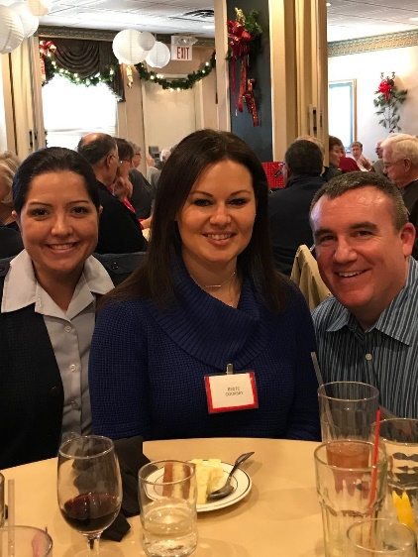
NGAA West award winner Beste Cooksey (center) and two friends, Sarah Hoffman and Adam Bruce. Photo by Jim Boyd

Paulette then introduced the members of the board who were in attendance and thanked them for all that they accomplished throughout the year. She asked that if anyone present was interested in filling a position on the board, to let a board member know. She then asked all new members and guests to introduce themselves. She gave the dates of the luncheons next year: March 28, June 27, September 26 and December 12. She thanked the people who filled out the sheets that were put on the tables, asking members to pick the top three activities they’d like to see happen in 2018.

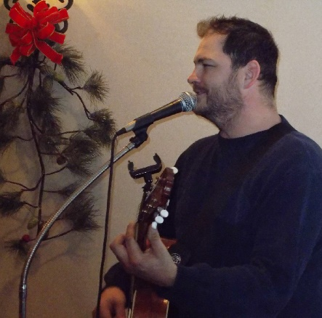
During lunch we were entertained by Pat White, and of course, he played some Christmas music. (Photo: Frank Aufmuth.)

There were 21 50/50 winners of $5– Libby Lanning, Claire Andracsek (2), Betty Dummeyer, Donna Pekarek (2), Joanne Moran, Ed de la Pena, Bob Bentrup, Lou Decker (2), Kent Kenniston, Dennis Terhaar, Nick Decker, Pat Keller, Mary Decker, Kathy Pozzo, Fred Meister, Denny Dummeyer, Harold Adams and Grace Boyd. Winners of the popcorn tins and cookies were Lou Decker (2), Joanne Moran, Ruth Walters, Bob Bentrup, Dennis Terhaar, Adam Bruce, Marilyn Lanning and Mary Decker.

Renewal of DoD Retiree ID Cards

Members of NGAA West wanting to obtain and renew their DoD Civilian Retiree Identification Card need to do the following.

First, contact NGA's Workforce Service Center-West and set up an appointment. The office telephone number is 314-676-3350. Next, you will be required to give the office the following: your full name, driver's license number, state of the license’s issue and the license expiration date. On receipt of this information they will submit a Visitor Access Request to NGA's Office of Security and set up an appointment for you to come to their office to receive your ID card.

You must bring two proofs of ID in original form. One must be a valid State or Federal government-issued picture identification (for example, passport or driver's license). If you have question, contact James G. Mohan, 314-676-3246.

New Members

Nancy J. Rogers

James R. Rothove

Other Changes or Corrections

Penny Chesnut

Thomas N. Dodillet

Joyce A. Hoffman

Ronald J. Hoffman

Linda L. Mooy

SICK MEMBERS / FORMER WORKERS / FAMILY

Edward M. Black Ron Foster
Norma Doolin Joel Frazer
Shirley A. Duncan Carol Stamer
Tony Ferguson James Waskow
Herman Westrich

NGAA West members extend sincerest sympathy to loved ones and friends.

R
EST

IN

P
EACE

Please keep these departed in your thoughts and prayers.

William Stiles November 18
Robert Franklin November 22
Lois Tomazi November 25
Paul Gegg November 26
Jeter Thompson December 1
Louis E Greco December 4
Jon Kilburn December 4.
Harold Gill December 11
Robert Montgomery December 21
Gertrude Gerszewski December 24

Barbara Savalick January 14.
Steve Telford January 24
John Fierst January 30
Peter Stickl February 1
Paul French February 5
Ralph Imhof February 13

Alive and Well
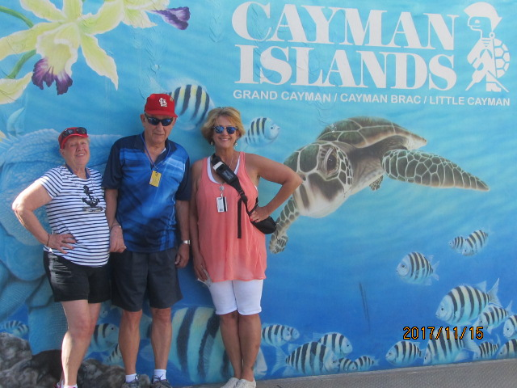

Our Trip to Cozumel and the Caymans –Ron Cramer

On November 12 to 19 last year, Ron and his family visited Cozumel, Mexico, Jamaica and Grand Cayman Island aboard the cruise ship Liberty of the Sea. “The picture is my wife Jan, myself and our daughter Rhonda Wind. Next year we will be doing two European cruises.”
2018 Board Members

Paulette Martin Chair
314-892-9009 plettem@yahoo.com
Marilyn Chryst Senior Advisor
314-845-2497
Frank Aufmuth President
314-892-3841 aufmuth@juno.com
Walt Rohn Vice President Membership
314-882-5083 superwalt13@gmail.com
Pat Wiese Secretary / Hospitality Chair
314-385-7845 patwiese1@aol.com
Jerry Lenczowski Treasurer
314-842-1767 jerome.lenczowski@sbcglobal.net
Kay Strebeck Co Treasurer
314-984-9183 kstrebeck236@sbcglobal.net
Pat Reed Mailing Committee Chair
314-846-4491 preed2578@aol.com
LeRoy Schmieder Member-at-Large
314-846-5180 Lschmieder456@aol.com
Robert Pankey Webmaster
636-566-0050 rfpsouthpaw@gmail.com
Wells Huff VP Communications /Newsletter Editor
314-352-5506 wellshuff@sbcglobal.net

TREASURER’S REPORT

The NGAA West Accounts activity for
November 10, 2017 to February 28, 2018:

SAVINGS:
11/09/2017 Balance $ 8767.98
11/30/17- 1/31/18 Interest $ 2.10
12/11/2017 Transfer to Checking for Luncheon $ 2000.00
12/16/20177 December Luncheon & 50/50 $ 1625.00
02/28/2018 Balance $ 8395.10

CHECKING
11/09/2017 Balance $ 118.30
Checking Transactions Credit Debit
11/1/2017/- 01/31/2018 | Dividend | $0.69
11/09/2017- 2128/2018 | Deposit Dues | $660.00
12//11/2017 | December Newsletter and Mailing |  | $159.82
12/13/2017 | December Refreshments & Entertainment |  | $234.93
12/11/2017 | Savings Transfer for Luncheon | $2000.00
12/13/2017 | Luncheon Meals |  | 1680.00
1/1/2018 -2/28/2018 | NGAA_W Award Plaque |  | $84.93
1/23/2018 | Redeem Arsenal CD | 5002.85
1/08/2018 | Hospitality Expense |  | 71.98
1/15/2018 | 2018 October Picnic Reservation |  | 125. 00

02/28/2018 Balance $ 5,316.95

TOTAL DEPOSIT ACCOUNTS
02/28/2018 Balance $ 13,712.07

INVESTMENT FUNDS
CD 1200 Matured 01/23/2018 $ 0.00
CD 1202 Matures 07/09/2018 $ 4.206.94

TOTAL NGAA-WEST FUNDS $17,919.01
Treasurer’s Note: I am in the process, hopefully, of setting up a new CD with a 2.1% interest rate at Live Oak Bank as a Business Non-profit.
Jerry Lenczowski, Treasurer

NGA West Sports
Golf News
The ACS Golf season will begin April 19 at Missouri Bluffs course. The 2018 schedule and standings will be published on the NGAA West Home Page, www.ngaawest.org For further information on the league, contact Doug Nolte, nolted@att.net, or Randy Pratt, rdpratt@att.net.
Thursday Invitational Bowling League
Doug Nolte

The league has completed its 20th week of competition and the fight for first place is really heating up. It appears the Lounge Lizards, headed up by Don Giarraffa and Homer Ferrell, are into it with the Jollys, led by Roger Greenland and their spiritual leader Chuck Erpenbach. It'll be curious to see which team can outlast the other at the finish. The Jollys will have their hands full in the near future when they meet the crafty Stretch Runners spearheaded by Charley Wilson and his arsenal of every ball known to mankind. Also on this unpredictable team is one Dennis Terhaar, who has been known to unleash some high scores when least expected. A fun time for all.

As usual, for those who want to witness all this fun and unlimited excitement, we perform at Sunset Lanes on Watson Road real close to the intersection with Laclede. Time for this extravaganza is 4 p.m. on just about every Thursday from September into April.

Arsenal Mixed Bowling
Pat Wiese
The Arsenal Mixed League had an exciting first half of the season. It all came down to the final night. The Rollercoasters came out on top. The Rollercoasters’ team consists of Ruth Walters, Janis Schneider, Ernie South, and Denny Dummeyer. Their opponent was the Purple Turkeys – Marianne Norrenberns, George Manders, Diana Harwell, and Larry Henning.
After the position round in the second half, Fab Four - Art Von Rump, Lisa Deen, Debbie Neustadt, and Rich Flauaus have a slight lead. Hopefully, they can keep it up even though Debbie can’t finish the season with the team. She broke her right wrist when she slipped on the ice on her front porch just before Valentine’s Day. It was suggested she try bowling with her left hand for the rest of the season.
Barb Speiser suffered a stroke on New Year’s Day and won’t be able to return this season. Our thoughts and prayers are with her.
Points Report
By Jim Hilterbrand

Ten people attended the January luncheon. The attendees were Dave Alspaugh, Sam Brewer, Jim Hilterbrand, Jim Huettenmeyer, Don Neubacher, Kevin Perry, Gene Sylvester, Danny Wells, Dale Winters, and Jim Wynn. Several regulars have been unable to attend each month due to various reasons. Some of the attendees did not work in Points, but enjoy the comradery of the group. The Points Group meets at 11:00 the first Wednesday of the month at Golden Corral, located at 6110 South Lindbergh.

Negative Engravers Luncheons
Don Lippold

The December Luncheon was attended by Ed Black, John Carty, Pat Dickens, Bob Diekemper, Rich Egan, Millie Jackson, Libby Lanning, Harry Lemakis, Gus Ullo, Larry Weisz and Don Lippold.

John Carty, Rich Egan, Millie Jackson, Kent Keniston, Libby Lanning, Larry Weisz and Don Lippold showed up for the January luncheon.. At the February luncheon we had, John Carty, Elmer Filla, Harry Lemakis, Ernie South, Gus Ullo and Don Lippold.

Next month's luncheon will be March 8th at El Maguey 135 Concord Plaza at 12:30 pm.

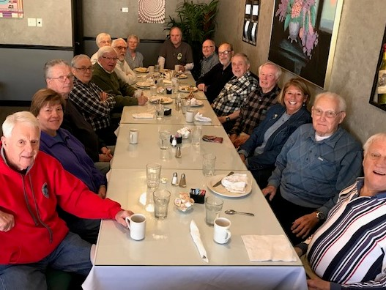
The Photo Lab's February 26 Breakfast
Retirees, friends and wives of the Photo Lab met for breakfast on February 26 at Ambrosia Restaurant and Bar on Gravois in Affton. We had a whopping 16 attending and it was a great opportunity to get caught up with each other. Pictured from left front to back and around the table are: Frank Aufmuth, Sharon Aufmuth, Tom Murphy, Ron Updegrade, Bob Edwards, Linda Frintrup, Jerry Frintrup, Norma Bernhardt, Warren Huff, Don "Bernie" Bernhardt, Pat Reed, Larry Henning, Dave Alspaugh, Paulette Martin, Fred Meister and .Bill Volk, The Photo Lab meets for breakfast on the 4th Monday of each month at 9 a.m. at Ambrosia's. The next two will be held on March 26 and April 23. All are invited to come!
14 Things You Can Do on Our Computer Home Page (NGAAWest.org)
Our Webmaster Bob Pankey has supplied a list of some of the proactive options you have with the data now posted on the NGAA West Home Page, including uploading your own information (photos or data). Bob is available to answer your questions about the uses and capabilities of our web site, general information and privacy concerns.
- See List of Members (Name, Spouse, Email)
- Download Member List to Your PC
- Create a Password for Your Use
- Change Your Personal Password
- Display Your Membership Record
- Request a Change in Your Membership Record
- Upload a File (Photo, Data or Both)
- Display Current NGAAWest Newsletter
- Display NGAAEast Newsletter
- Display NGAAWest Member Directory
- Display NGAAEast Member Directory
- Display Names of Recently Deceased Retirees
- Display NGAAWest By-Laws
- Display Photo and Video Gallery
Now You Can Apply On Line for NGAA West Membership
NGAA West Web Keeper Bob Pankey has created an on-line Membership Application form, using the revised Membership form created last fall by our treasurer, Jerry Lenczowski. Those who apply for membership now have the option of using the regular or the on-line form, at http://www.ngaawest.org/webform//membership2/join.html Applicants may pay annual or lifetime membership fees on line with a bank draft or by sending a check to NGAA West at the address shown on the cover on this newsletter.
Note that a discount of $40.00 on Lifetime Memberships is available to members of the Arsenal Credit Union.
NGAA West Events: ‘Save the Date’
NGAA West 2018 Quarterly Luncheons
Pietro’s, 3801 Watson Road
- Wednesday, June 27
- Wednesday ,September 26h
- Wednesday, December 12

Visit to Grant's Farm:
Saturday May 12th, 10 a.m. Frank Aufmuth

Grant's Farm. Meet at parking lot entrance. $10:00 per car to park. Shows start at 11:00 a.m. Frank Aufmuth (314) 893-3841, Grant's Farm (314) 843-1700. This is a family event, so bring the grandkids. It’s on a Saturday so they won't be in school.

Ball Park Village Lunch: Date TBD. Walt Rohn

Horse Hooky Tuesday, July 10th, Fairmont Race
Track. Paulette Martin

Arsenal Mixed Bowling 4 p.m. Wednesdays at Sunset Lanes

Men’s Invitational Bowling 4 p.m. Thursdays at Sunset Lanes

ACS Golf New season begins April 19. For schedule and standings see the NGAA West Home Page, www.ngaawest.org

Negative Engravers Luncheons
El Maguey restaurant in Concord Plaza
Second Thursday of the month at 12:30 p.m.

Photo Lab Breakfasts
Ambrosia Restaurant, 9416 Gravois Road in Affton
Fourth Monday of the month at 9 a.m.

Points Group
Golden Corral Restaurant, 6110 S. Lindbergh Blvd,
First Wednesday of the month at 11:00 a.m.

NGAA West Retirees’ Fall Picnic Monday, October 8. Cliff Cave County Park. Paulette Martin and Pat Reed.

NATIONAL GEOSPATIAL-INTELLIGENCE ALUMNI ASSOCIATION
MEMBERSHIP APPLICATION
(PLEASE PRINT CLEARLY)
- Name (Yours): Last ____________________________ First __________________________ Middle Initial _____
Preferred Name (Optional) _________________________ Birthday: ______________ (Optional)
- Retirement date (if applicable): _____________________
- Organization from which retired or transferred/current employment: ___________________________ (NGA, NIMA, DMA, Other affiliation)
Name of Spouse/Significant Other:
In the case where both spouses are members of the same chapter, only one fee will be assessed, unless the spouses desire their own membership. If one spouse is already a member, the other, if eligible in his/her own right, may join at no additional fee.
-Is spouse: A current/former Employee of NGA or predecessor organization: ___ Yes ___ No.
-Is he/she a current NGAA Member: ___ Yes ___ No. If yes, indicate Chapter(s): ___ NGAA-East ___ NGAA-West.
Main Address:
Street/PO Box: _____________________________ City/State: ________________________ Zip Code: __________

Phone: __________________ Cell/alternate phone: __________________ e-mail: ___________________________
Alternate Address (if applicable):
Street/PO Box: _____________________________ City/State: ________________________ Zip Code: __________
Phone: ___________________ Cell/alternate phone: __________________ e-mail: __________________________
Specify time period at alternate address: From: ______________ To: _________________
Please note that, while participation in Chapter informational/social functions is reciprocal, voting privileges are accorded only to dues-paying members of the specific chapter. Access to Chapter directories is accorded to dues-paying members of either Chapter. General information is in the public domain on the Chapter web sites. If you would like to be contacted by a member of either, or both, Chapters, please check here: ___Yes, NGAA West ___Yes, NGAA East.
Chapter affiliation desired (check one below).
________ NGAA WEST
Dues: $10.00/year or $100.00 Lifetime Membership*
Send this application, along with your check*, to:
NGAA West
P.O. Box 510091
St. Louis, MO 63151-0091
*The Arsenal Credit Union (ACU) will reimburse $40.00 toward the lifetime membership of $100.00 for any new applicant who has been a member in good-standing of ACU for a minimum of one (1) year, provided that the applicant’s retirement occurred after January 31, 2013. If you qualify, please provide your ACU account number: _____________. Send your check with your application. After we have processed your application, we will notify ACU of your membership. ACU will then credit your account with $40.00.
________ NGAA EAST
Dues: $40.00 – Lifetime Membership* Send this application, along with your check*, to:
NGAA East
Paul Mich, Treasurer 1308 Rock Chapel Road Herndon, VA 20170
*Our sponsor, Constellation Federal Credit Union (CFCU), has offered to pay the current $40 NGAA-East lifetime membership fee for eligible members of CFCU. If you have been a member for two-plus years, and if CFCU has not previously funded your membership in AMS, please fill in your credit union account number: #_____________. Send NO CHECK. We will notify CFCU of your application.

NGAA West

P.O. BOX 510091

ST. LOUIS MO 63151-0091

